JUST ADDED!!

Athlete’s Name: ________________________________________________________________ DOB:_________________________
Email: _____________________________________ Primary Phone Number: __________________________________________

Address: ______________________________________________ City: _______________________ Zip Code: _______________ Questions/concerns? Contact: □ Participant □ Other - Name/Relation: ______________________ Phone #: _______________
This league is for athletes who love this backyard sport or anyone who would like to learn how to play. The complete season is six weeks. The last session will be our
championship tournament with every athlete earning an award. There will not be same day registration. Make sure you call to register your spot!

When: Tuesdays, July 13th-August 17th
Time: 5:30-6:30
Where: 701 S. Main St Akron, Ohio 44311(UDS)
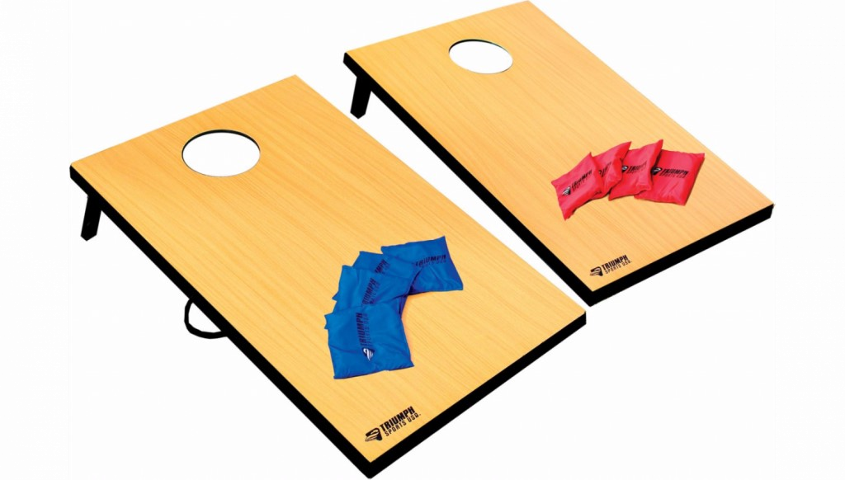
Cost: $50

Questions:
Program Information Registration Information
Dan Lancianese Jeff Campano
330-352-5602 330-762-9755, ext. 233
dlancian22@gmail.com jcampano@udsakron.org
PAYMENT OPTIONS  (  )  Please select the best option. | □ PRIVATE PAYMENT: Total Payment Enclosed $_____________  Please return all forms to:  ◻ Check # _________ (Made out to United Disability Services) ◻ Money Order    United Disability Services  - Credit Card: □ Visa □ MasterCard □ Discover 701 S. Main St., Akron, OH ⁴⁴³¹¹   Name on Credit Card: ______________________________ Billing Zip Code: ____________ Total Payment: __________     Credit Card Number______________________________________ 3 digit CV#________________ Exp. ______________  Signature_________________________________________________ Date: ______________________________________  - WAIVER - If possible, I would like to use my waiver to pay for my participation. I have contacted my SSA about using my waiver funds for my participation and I give my permission for my SSA to discuss the details with UDS.  My Waiver is a(n): ◻ IO Waiver ◻ Level 1 Waiver ◻ SELF waiver ◻ Other ________________ □ Not Sure  Medicaid Number: ______________________________ SSA Name: ______________________ □ Summit County  - Other:___________
For office use only: |  | Form Processed: | Annual Waiver on File: | Photo Release: | Other:

